Project Report: Analysis of Investment Behavior Patterns

Overview of the Project Domain
This project falls under the domain of financial behavior analysis, specifically examining how demographic factors influence investment preferences and financial decision-making. The analysis explores real-world investment patterns among individuals, providing insights that could inform financial education programs, product development, and market strategies.

Introduction
The dataset contains survey responses collected during the COVID-19 lockdown period, capturing various aspects of investment behavior, preferences, and demographics. It includes:
- Demographic information (gender, age)
- Investment preferences across different instruments
- Factors influencing investment decisions
- Monitoring habits and investment objectives
- Sources of financial information

Data Source Link
Dataset: Finance_data.csv
Source: Kaggle - https://www.kaggle.com/datasets/nitindatta/finance-data/data/code
Link: https://github.com/BluPhan/CSCSTCS

Description of the Problem/Questions Explored
Primary Research Question: "How do gender, age, and investment preferences intersect in determining financial behavior patterns?"

Data Cleaning Steps
The following data cleaning procedures were implemented in the Python notebook:
Initial Data Inspection
- Examined data types using `data.info()`
- Checked for missing values using `data.isna().sum()`

Missing Value Handling
No significant missing values were found in key demographic columns (gender, age)
Minor missing values in other columns were retained as they didn't affect core analysis

Data Type Verification
- Confirmed appropriate data types for analysis
- Categorical variables properly identified for visualization

Consistency Checks
- Verified age ranges for logical consistency
- Checked gender categories for standardization

Dashboard Explanation and Insights
Dashboard Component 1: Gender Distribution in Investment Participation
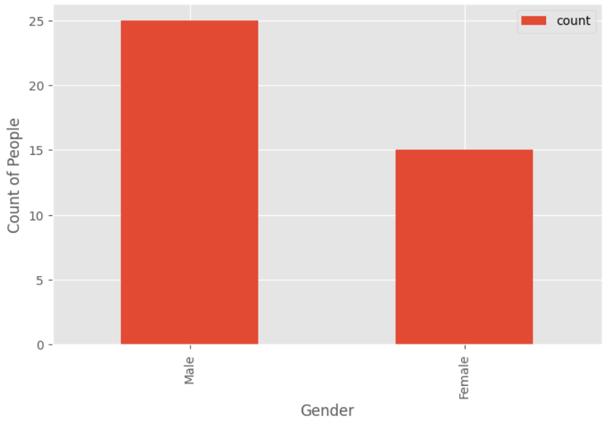
Bar chart showing count of investors by gender
Insight: Male investors significantly outnumber female investors in the dataset, suggesting gender disparities in investment participation or survey response rates.

Dashboard Component 2: Age Distribution Analysis
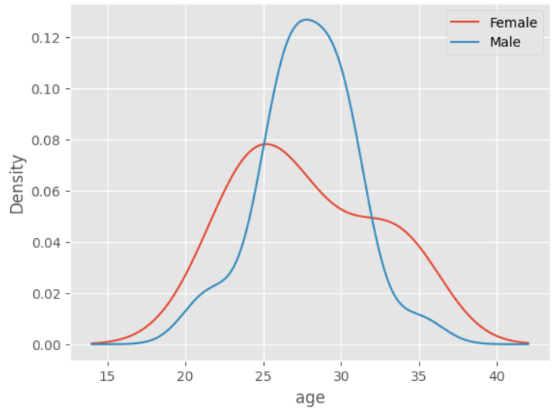
Kernel Density Estimation (KDE) plot showing age distribution by gender
Insight: Peak investment activity occurs between ages 25-31 for both genders, indicating this life stage as critical for financial engagement initiation.

Dashboard Component 3: Investment Preference Analysis
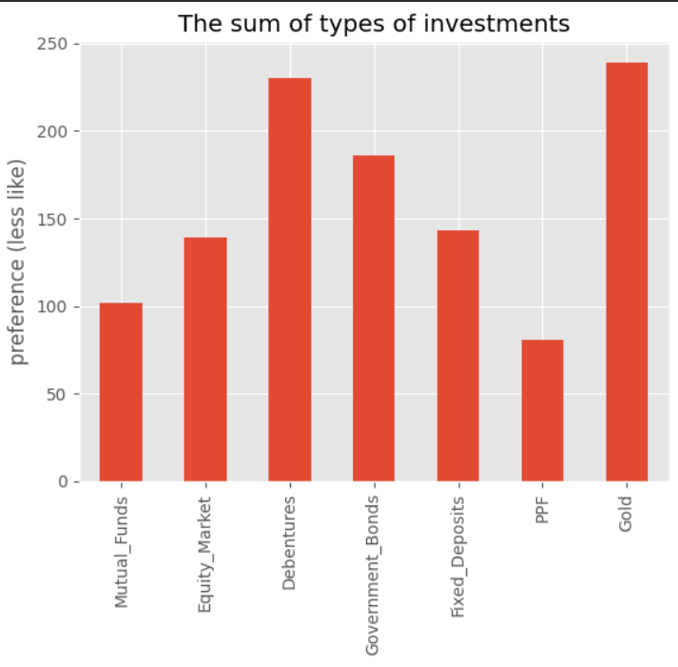
Bar chart showing preference rankings across investment types
Insight: Public Provident Fund (PPF) is the most preferred investment instrument, followed by Government Bonds and Fixed Deposits, indicating a conservative investment approach.

Key Findings and Insights
Demographic Patterns
- Gender Gap: Significant male predominance in investment activities
- Age Concentration: 25-31 years represents the most active investment period
- Conservative Approach: Preference for secure, government-backed investments across demographics

Behavioral Insights
- Risk Aversion: Strong preference for low-risk investment instruments
- Information Seeking: Financial consultants and traditional media remain primary information sources
- Monitoring Habits: Monthly monitoring is most common, aligning with medium-term investment horizons

Conclusion
The analysis reveals that investment behavior is strongly influenced by life stage (peaking at 25-31 years) while showing significant gender disparities in participation rates. The conservative investment preferences observed suggest risk-averse financial attitudes among respondents. These findings highlight opportunities for:
Developing age-specific financial products
Creating gender-inclusive investment initiatives
Designing financial education programs targeting younger adults
The dashboard effectively communicates these insights through clear visualizations that tell a cohesive story about demographic influences on financial behavior, meeting the project requirements for meaningful data storytelling.

Repository: https://github.com/BluPhan/CSCSTCS

